# PROJECT

(SEMINAR)

# CodeWeaver: HTML & CSS Generator

**Instructor** – Mr. Naveen Sharma

**H.O.D.** – Dr. Rita Chhikara

**Submitted by:**

Aashna Bansal (22CSU006)

Raghav Vats (22CSU142)

Rudra Rishi (22CSU249)

Kritika Yadav (22CSU310)

A Report

On

# CodeWeaver: HTML & CSS Generator

**Submitted to:**

Mr. Naveen Sharma

Table Of Contents

|  |  |  |
| --- | --- | --- |
| **S.NO** | **CONTENTS** | **PAGE NO.** |
| **1.** | **Abstract** | **4** |
| **2.** | **Introduction** | **5** |
| **3.** | **Tech Stack** | **6** |
| **4.** | **Implementation** | **9** |
| **5.** | **Results** | **10** |
| **6.** | **Conclusion** | **14** |
| **7.** | **References** | **15** |

ABSTRACT

This report details the development of a Java-based graphical user interface (GUI) application for generating HTML and CSS code. The application provides a visual environment for users to create and manipulate HTML elements, apply styling, and preview the resulting code. It leverages the Java Swing library for its GUI components and implements an object-oriented approach to represent HTML elements. Key features include support for various HTML elements, text formatting, color customization, a dark mode option, and undo/redo functionality. This tool aims to simplify HTML and CSS code generation, particularly for users who prefer a visual, interactive approach.

INTRODUCTION

Web development relies heavily on HTML for structuring content and CSS for styling its presentation. While many tools exist for web development, a need remains for intuitive tools that allow users to generate HTML and CSS code visually. This project addresses this need by presenting a Java-based GUI application that enables users to create HTML elements, apply styles, and see the resulting code in real-time. The application utilizes Java Swing to provide a cross-platform interface and implements an object-oriented design to manage HTML elements programmatically.

This application aims to bridge the gap between visual design and code, offering a more accessible approach for users who may not be proficient in hand-coding HTML and CSS. The visual interface allows users to drag and drop elements, modify styles using intuitive controls, and instantly see the corresponding code. This can significantly speed up the development process and reduce the learning curve for beginners. Furthermore, the generated code can be used as a starting point for further customization or integration into larger web projects.

This report outlines the design, implementation, and features of this HTML/CSS generator, demonstrating its potential to streamline the web development workflow.

TECH STACK

The CodeWeaver application is built using Java, employing the following technologies and libraries:

* **Language:** Java
  + The core language is Java. This provides platform independence, object-oriented capabilities, and a rich ecosystem of libraries.
* **GUI Library:** Swing
  + The application's graphical user interface (GUI) is built using the Swing library. Swing is a part of the Java Foundation Classes (JFC) and provides a set of lightweight components for creating cross-platform desktop applications.
  + Swing components are written in Java, allowing for a consistent look and feel across different operating systems.
* **Swing Components:**
  + The application utilizes a variety of Swing components:
    - JFrame: The main window of the application. The application uses frame.setDefaultCloseOperation(JFrame.EXIT_ON_CLOSE); which ensures that the application exits when the user closes the main window.
    - JPanel: Used as a container to organize and group other GUI components. The application uses controlPanel.setBorder(BorderFactory.createEmptyBorder(15, 15, 15, 15)); to add padding around the control panel.
    - JButton: Interactive buttons for user actions such as "Undo", "Redo", and "Preview". The application also uses a custom RoundedBorder for the buttons.
    - JTextArea: The outputArea component is used to display the generated HTML code.
    - JComboBox: Dropdown lists (fontFamilyCombo, fontSizeCombo, alignmentCombo) for selecting options like font, font size, and alignment.
    - JToggleButton: A toggle button (darkModeToggle) to enable or disable dark mode.
    - JColorChooser: Used in conjunction with JButton to allow users to select colors.
* **Layout Managers:**
  + The application employs specific layout managers to structure the arrangement of GUI components:
    - BorderLayout: Used for the main frame to organize components into regions like North, South, East, West, and Center.
    - BoxLayout: Used within the controlPanel to arrange components vertically.
* **Styling:**
  + The application applies custom styling to enhance the user interface:
    - Font settings: Users can select font families and sizes using JComboBox components, and the selected font is applied to the text.
    - Colors: Users can choose text colors and background colors for elements, as well as the overall page background color.
    - Borders: The application uses a custom RoundedBorder class to give buttons a rounded appearance.
* **Event Handling:**
  + The application uses event listeners to handle user interactions:
    - ActionListener: Used to respond to button clicks, triggering actions like undoing, redoing, and previewing the HTML output.
    - ItemListener: Used to detect changes in the selected items in the JComboBox dropdown lists, such as font family, font size, and alignment. This allows the application to dynamically update the style of the HTML elements

IMPLEMENTATION

The CodeWeaver application is a GUI-based HTML editor with the following key features:

* **HTML Element Representation:** The HtmlElement class and its subclasses (Heading, Paragraph, Span, Link, HtmlImage, and ListElement) represent HTML elements in an object-oriented manner. This allows for programmatic manipulation of the HTML structure.
* **HTML Structure Management:** The HtmlRoot class manages the hierarchy of HTML elements, providing methods for adding, removing, and manipulating elements. It also implements undo/redo functionality using a history of element states.
* **GUI Components:**
* JTextArea (outputArea): Displays the generated HTML code.
* JButton: Provides interactive controls such as "Undo", "Redo", "Preview", color selection, and page background color.
* JComboBox: Allows users to select font family, font size, and text alignment.
* JToggleButton: Enables/disables dark mode.
* **Functionality:**
* **Undo/Redo:** The application supports undo and redo operations for HTML element modifications.
* **Text Formatting:** Users can apply formatting options such as font family, font size, text color, and text alignment to selected HTML elements.
* **Element Styling:** Users can change the background color of elements.
* **Page Background Color:** Users can set the background color of the entire HTML page.
* **Dark Mode:** The application offers a dark mode option for improved user experience in low-light conditions.
* **HTML Preview:** The application generates and displays the HTML code based on the user's actions.
* **Event Handling:** The application uses event listeners to handle user interactions with the GUI components. For example, ActionListener is used for button clicks, and ItemListener is used for dropdown selections.
* **Custom GUI Styling:** The application uses a custom RoundedBorder class to create buttons with rounded corners and allows for consistent styling of GUI elements.

RESULTS

Application  
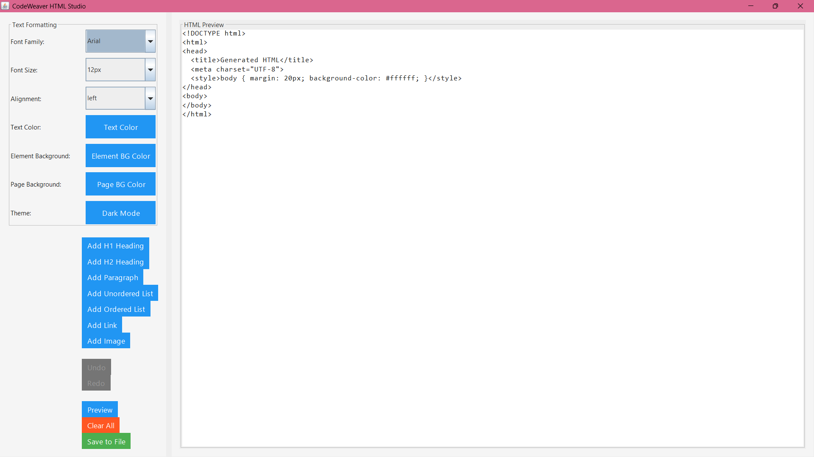

Preview 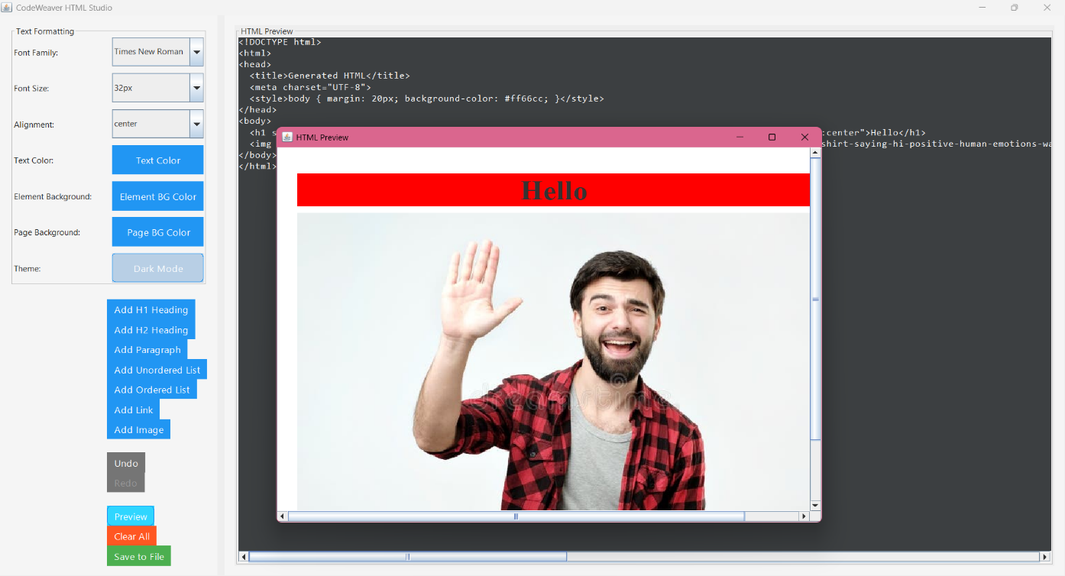

Final Output

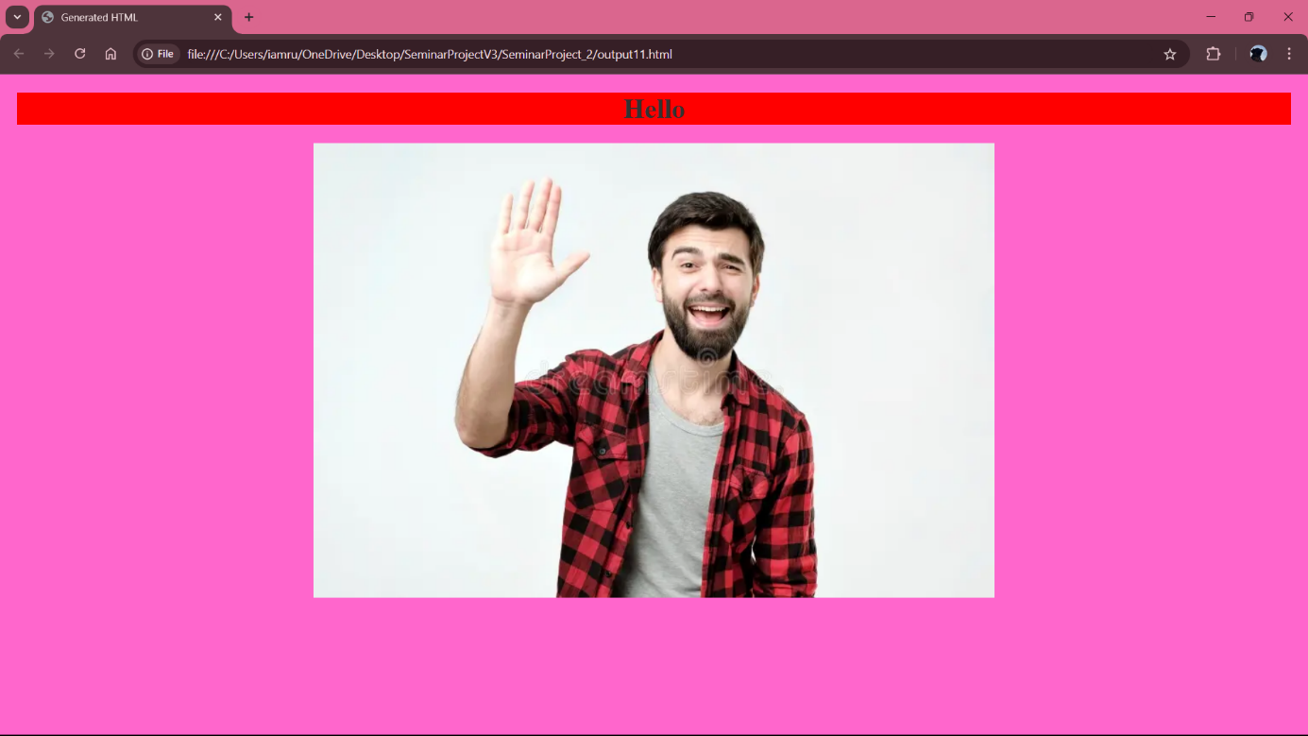

Features

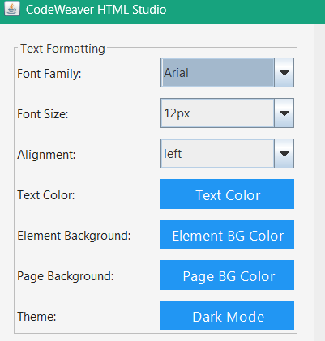

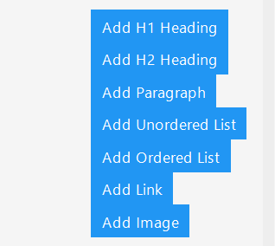

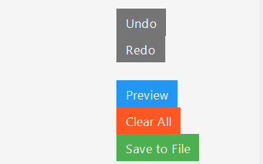

CONCLUSION

This report detailed the development of CodeWeaver, a Java-based GUI application designed to facilitate the generation of HTML and CSS code. The application provides a user-friendly, visual approach to web development, allowing users to create and manipulate HTML elements, apply styling, and instantly preview the resulting code. By leveraging the Java Swing library and implementing an object-oriented architecture, CodeWeaver offers a cross-platform solution with features such as support for various HTML elements, text formatting, color customization, dark mode, and undo/redo functionality.

This tool has the potential to simplify the web development process, particularly for those who prefer a visual interface or are new to web development. The intuitive design and real-time preview can accelerate the creation of web page structures and styles. Furthermore, the generated HTML and CSS code can serve as a foundation for more complex web projects, allowing developers to extend and customize it as needed. While CodeWeaver focuses on providing a visual generation tool, future development could explore features such as more advanced CSS styling options, support for JavaScript integration, and the ability to import and export existing HTML/CSS files.

REFERENCES

1. Java Swing Documentation: [docs.oracle.com/javase/tutorial/uiswing/](https://docs.oracle.com/javase/tutorial/uiswing/)
2. HTML Standard: https://html.spec.whatwg.org/
3. CSS Styling: https://www.w3.org/Style/CSS/
4. A Beginner's Guide to HTML: [www.w3schools.com/html/](http://www.w3schools.com/html/)
5. CSS Tutorial: https://[www.w3schools.com/css/](https://www.w3schools.com/css/)